**MEDICAL WASTE MANAGEMENT**

**Infectious Waste:** Infectious waste is a significant concern because it can contain pathogens like bacteria, viruses, and other microorganisms. This waste includes items contaminated with bodily fluids, such as blood-soaked bandages, used gloves, and medical equipment that have come into contact with potentially infectious materials. **Around 15-25%** of medical waste may be considered infectious, as it includes materials like used gloves, contaminated bandages, and items with bodily fluids.

**Sharps Waste:** Sharps waste, which includes items like needles, syringes, and lancets, poses a high risk of injury and potential transmission of bloodborne diseases. Improper disposal of sharps can lead to needlestick injuries and the spread of infections. Sharps waste typically constitutes about **5-10% of medical waste**. This includes items like needles, syringes, and lancets.

**Radioactive Waste:** Radioactive waste is relatively small and might account for less than **1% of medical waste**, as it's generated mainly from specific procedures.

**Non-Hazardous/General Waste:** Non-hazardous or general waste, such as paper, packaging, and food waste, could make up **40-50% of the total waste generated in healthcare facilities**.

**Pharmaceutical Waste:** Expired, unused, or contaminated medications fall into this category. Pharmaceutical waste can be hazardous to the environment and public health if not disposed of properly. Certain pharmaceuticals can leach into water sources, harm aquatic life, or end up in the food chain. Pharmaceutical waste might account for **5-10% of medical waste**, depending on the scale of healthcare activities and the extent of drug usage.

**Chemical Waste:** Chemical waste includes laboratory chemicals, disinfectants, cleaning agents, and other substances used in healthcare settings. Some of these chemicals can be highly toxic, corrosive, or flammable. Improper handling or disposal of chemical waste can result in environmental pollution and health risks. Chemical waste could represent around **5-10% of medical waste,** varying based on the types of chemicals used in the facility.

**Pathological Waste:** Pathological waste may constitute a small percentage, perhaps around **1-5%** of the total waste, as it involves tissues and organs from surgeries and autopsies.

**Anatomical Waste:** Anatomical waste could also be a small fraction, around **1-5%,** depending on the presence of research or educational activities involving preserved body parts.

**Cytotoxic Waste:** Cytotoxic waste is generated from cancer treatment procedures and contains drugs that are toxic to cells, including cancer cells. Handling and disposing of cytotoxic waste require careful attention to prevent exposure to healthcare workers and potential contamination of the environment. Cytotoxic waste might account for a relatively low percentage, around **1-3%** of medical waste, due to the specific use of cytotoxic drugs in cancer treatment.

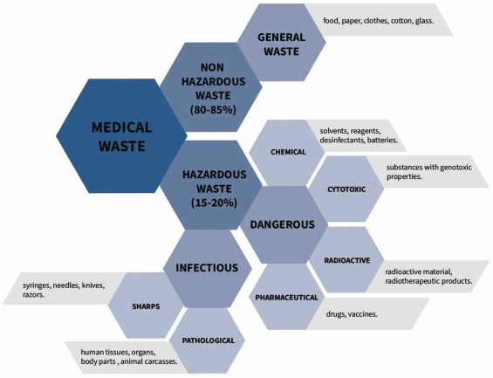

**What waste are we going to deal with:**

Infectious Waste

Sharps Waste

Pharmaceutical Waste

Radioactive Waste

Chemical Waste

Cytotoxic Waste

Each of these waste types has its own set of regulations and guidelines for proper handling, segregation, storage, transportation, and disposal.

**“hazardous waste category could vary depending on the context and location. For instance, in a healthcare setting, infectious waste and sharps waste might be more common due to medical procedures, while in an industrial setting, chemical waste could be more prevalent. Similarly, the handling and disposal regulations for these types of waste can vary by region, so what's considered a major concern in one area might be different in another.”**

**The top 3 wastes we have selected since they are in major quantities of hazardous waste?**

Chemical Waste, Cytotoxic Waste, Infectious Waste, Pharmaceutical Waste

**Major Ways of Treating Medical Waste**

**Incineration** - <https://en.wikipedia.org/wiki/Incineration>

**Steam Sterilization** - <https://www.azom.com/article.aspx?ArticleID=18733>

**What are the major chemicals released in medical waste**

**VOCs, Furan and Dioxins, Anti Resistant Gene**

**How we are going to treat: Incineration**

**What are the major byproducts after Incineration?** 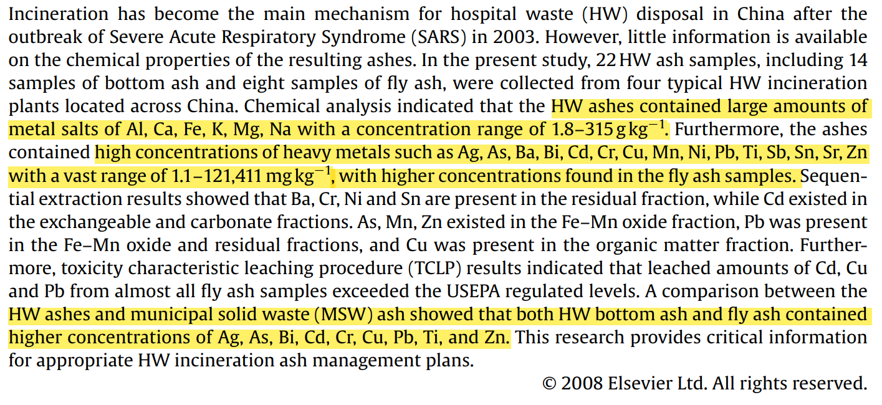

**How will the dust going to affect the environment?**

Dust generated from medical waste can potentially have negative effects on the environment if not properly managed. Medical waste can contain various hazardous materials, including infectious agents, chemicals, pharmaceuticals, and other contaminants. When these materials are mishandled and generate dust, several environmental concerns arise:

**Spread of Pathogens**: If medical waste contains infectious materials, such as used medical supplies or contaminated personal protective equipment, the dust generated from these items can carry pathogens into the air. These pathogens may include bacteria, viruses, or other microorganisms that can cause diseases. This could potentially lead to the spread of infections if the dust is inhaled or comes into contact with people or animals.

**Air Quality**: The release of dust into the air can contribute to air pollution. If the dust contains chemicals, particulates, or other pollutants, it can degrade air quality and potentially have adverse health effects on humans and wildlife in the vicinity.

**Soil Contamination:** Wind can carry medical waste dust to nearby soil and water bodies. This can contaminate soil and water with hazardous substances, including pharmaceutical residues, heavy metals, and pathogens, which can have long-term environmental impacts.

**Water Pollution:** If dust is carried by wind or rain into water bodies, it can contribute to water pollution. Chemicals and contaminants from medical waste can leach into the water, potentially harming aquatic ecosystems and affecting the quality of drinking water sources.

**Ecological Impact:** Contaminated dust settling on vegetation, plants, and soil can affect local ecosystems. Harmful substances can disrupt natural processes, harm plant and animal life, and potentially lead to long-term ecological imbalances.

**Human Health Risks:** Inhalation or direct contact with medical waste dust can pose health risks to individuals exposed to it. This includes healthcare workers, waste handlers, nearby residents, and anyone coming into contact with the contaminated environment.

**Cytotoxic Waste:** Cytotoxic waste is waste associated with cytotoxic drugs which contain chemicals that are toxic to the cells. This includes materials, equipment, and residue that are contaminated by cytotoxic drugs.

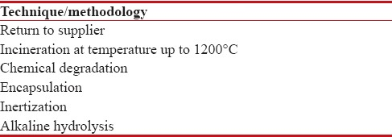

**How the waste gonna be treated:** **Incineration**

**Health Risks:**

allergic reactions

risk of mutation and formation of abnormal cells

severe soft tissue damage

Abdominal pain and liver damage

hair loss

possibility of fetal loss in pregnant women

nausea and vomiting

**Article about treating Cytotoxic waste:** [**https://www.ncbi.nlm.nih.gov/pmc/articles/PMC5582558/**](https://www.ncbi.nlm.nih.gov/pmc/articles/PMC5582558/)

**Harmful Metals Released After Land Filling:**

The ash produced is comprised of dioxins, heavy metals, chlorides, and carbon constituents Metal salts Al, Ca, Fe, K, Mg, Na with a concentration range of 1.8–315 g kg−1.

**HEAVY METALS:** Ag, As, Ba, Bi, Cd, Cr, Cu, Mn, Ni, Pb, Ti, Sb, Sn, Sr, Zn with a vast range of 1.1–121,411 mg kg−1, with higher concentrations found in the fly ash samples.

**VOCs are the most dangerous for the environment which are produced during incineration**

**Article:** [Content and Formation Cause of VOCs in Medical Waste Non-incineration Treatment Project - IOPscience](https://iopscience.iop.org/article/10.1088/1755-1315/113/1/012005/meta)

**Furan and Dioxins**: [Dioxins and their effects on human health (who. int)](https://www.who.int/news-room/fact-sheets/detail/dioxins-and-their-effects-on-human-health)

**Anti Resistant Gene:** <https://www.sciencedirect.com/science/article/pii/S0048969720325596>

**Useful Journals:**

# Ikehara, T., & Takahashi, H. (2013). Latest insights on technologies for the treatment of solid medical waste: A review. Procedia Environmental Sciences, 18, 625-634.

# Full Article: <https://www.sciencedirect.com/science/article/pii/S2213343723000489#sec0160>

Huda, T. M. N., Nath, S. R., & Akhter, S. (2020). **Medical Waste Management in Bangladesh**: A Review. Risk Management and Healthcare Policy, 13, 579-585. doi:10.2147/RMHP.S252622

**Full Article**: <https://www.ncbi.nlm.nih.gov/pmc/articles/PMC7127159/>

# Chemical properties of heavy metals in typical hospital waste incinerator ashes in China –

# Full Article <https://www.ncbi.nlm.nih.gov/pmc/articles/PMC7127159/>

# Impact of heavy metals on the environment and human health:

# Full Article <https://www.sciencedirect.com/science/article/pii/S1018364722000465>

# Heavy metal pollution in the environment and their toxicological effects on humans

# Full Article https://www.sciencedirect.com/science/article/pii/S2405844020315346

**Medical Waste management and control:**

**Full Article**: <https://www.scirp.org/journal/paperinformation.aspx?paperid=25649>

**References**

World Health Organization. (2021). **Health-care waste.** Fact Sheet.[**https://www.who.int/news-room/fact-sheets/detail/health-care-waste**](https://www.who.int/news-room/fact-sheets/detail/health-care-waste)

# Ikehara, T., & Takahashi, H. (2013). Latest insights on technologies for the treatment of solid medical waste: A review. Procedia Environmental Sciences, 18, 625-634.

# Full Article: <https://www.sciencedirect.com/science/article/pii/S2213343723000489#sec0160>

Huda, T. M. N., Nath, S. R., & Akhter, S. (2020). **Medical Waste Management in Bangladesh**: A Review. Risk Management and Healthcare Policy, 13, 579-585. doi:10.2147/RMHP.S252622

Full Article: <https://www.ncbi.nlm.nih.gov/pmc/articles/PMC7127159/>

**Chatgpt:** [**https://chat.openai.com/**](https://chat.openai.com/)